  
**Dynamic Energy Group**

Environmental Control Program - Extended Proposal

Tayvon Lewis

John Untivero

Adam Phillips

The Environmental Control Program is meant to regulate temperature per room within a structure using thermometers in each room to regulate temperature autonomously. Ideally, a building that meets temperature equilibrium will not have “hot” and “cold” areas, but will have evenly adjusted temperatures. There are three phases to temperature control within a structure. For the purpose of this example, we will identify the structure as “ThermoHouse”.

The first phase is to set the ThermoHouse program to the number of rooms that would require temperature control. The program must know how many rooms are going to be monitored and maintained(image1). Additional data includes the geographical location(image2) of each room to account for east/west facing windows that may add to the temperature and give those rooms slightly less “Attention”, as they will be receiving sunlight as an additional heat source.

The second phase of the ECP will introduce ideal temperature settings for each room within the program. This is no different than a normal setting a user would determine for their own comfort through their thermostat. Once that ideal temperature is received, that ideal setting is stored and constantly monitored(image3).

The third phase of the program uses the “Main” program of ThermoHouse for each room to receive temperature data in order to know when to close vents to prevent further heating or cooling based on the temperature of that room. Once the room has met its desired temperature, the ventilation will reopen in that room to allow normal heating and cooling procedures. The thermostat readings will be sub-classes that report to the parent class which is the ventilation control system. The heating/cooling unit itself will not change it’s output, allowing closed vent tubing to cycle that heat or air back toward areas that still have open vents, warming or cooling them in less time, turning off the unit at erarlier intervals and saving energy costs with the unit running for less time.

IMAGE-1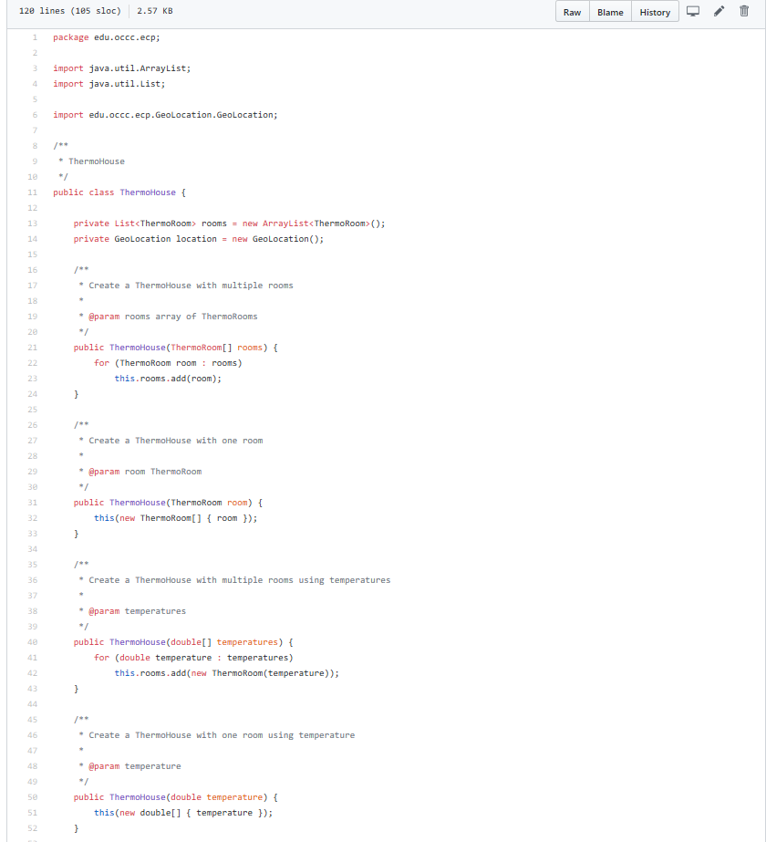

IMAGE-2

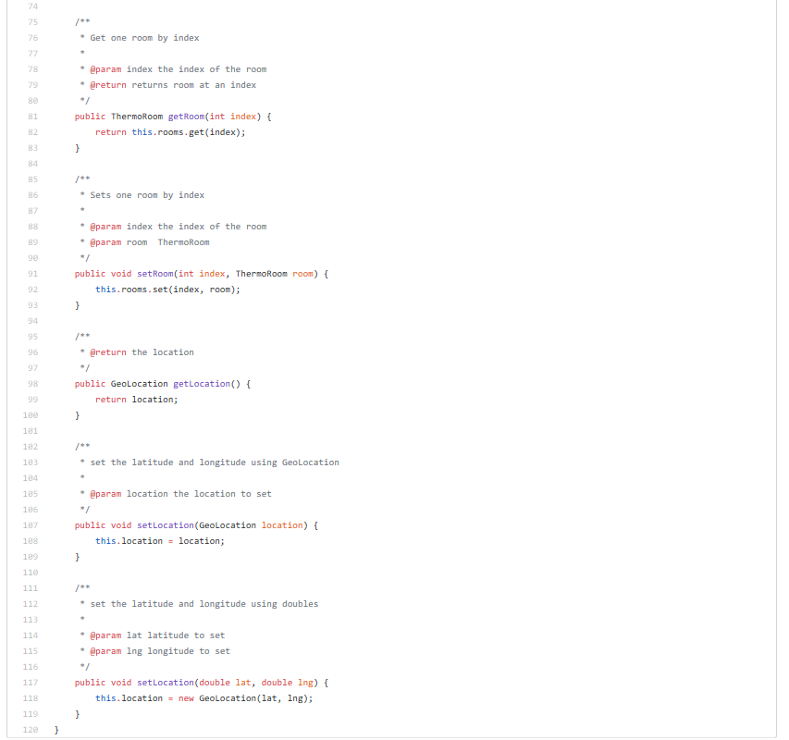

IMAGE-3

